IST Direkte
User guide for parents and guardians

February 2018

Contents

Contents 2
IST Direkte for parents and guardians 3
Login for parents and guardians 3
Primary services for a logged-in parent or guardian 4
Arrangements 4
Illness 4
Days off 4
Messages 4
Other services for a logged-in parent or guardian 6
Notice board/The blackboard 6
The child 6
Arrangements 7
Holidays/Days off 9
Activities 9
Events 10
Contacts 10
Staff 10
Timetable 10

IST Direkte for parents and guardians
IST Direkte is a communication tool for use between parents or guardians and after school care centre staff. Parents and guardians can:
- Register absence due to holidays or illness
- Register times when the pupil is to go home and when he or she has play dates
- Update contact information
- Exchange messages with the unit
- Obtain information from the unit/department
Parents and guardians log in at www.oslo.direktesfo.no from a PC, tablet or smartphone. Irrespective of the choice of unit, parents and guardians have access to the same functionality.

Login for parents and guardians
Parents and guardians log in to IST Direkte using MinID via the website www.oslo.direktesfo.no.
Parents and guardians first see a summary of the child/children they have enrolled in the after school care centre/preschool. The parent or guardian can highlight one of their children to see additional services available for that child.
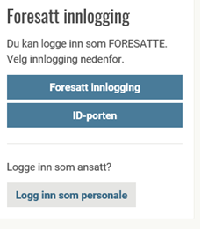
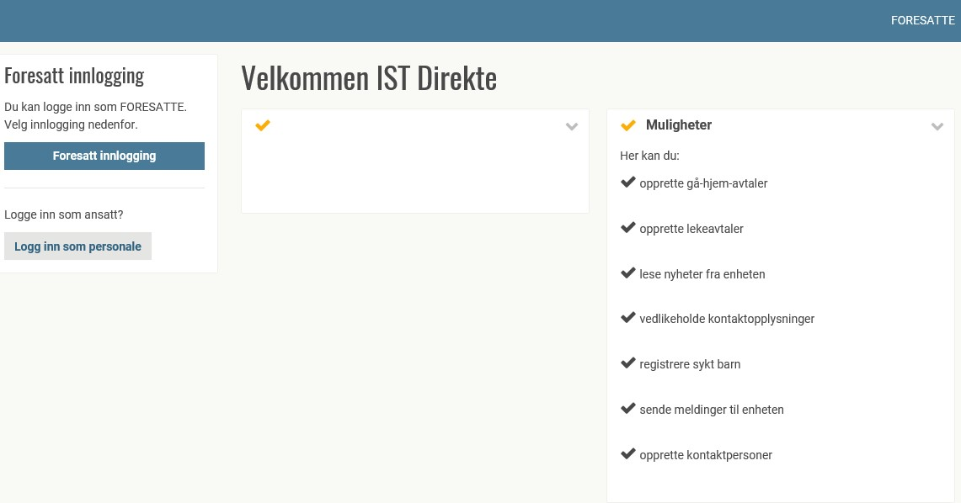

Primary services for a logged-in parent or guardian
Three primary services are displayed in the top right corner:

Arrangements
Option for creating arrangements. For example, that the child “will be collected by his or her grandfather at 15.00 every Wednesday".

Illness
Option for registering absence due to illness. Absence is indicated for that day or for the next day. It is also possible to write a comment/message to the unit/department when registering an absence.

Days off
Option for registering own days off. Days off can be registered for just one day, for several days or for recurring days.

Messages
Under Messages in the menu, users can create a message or receive messages from the unit/department. This part of the system will not be used during the pilot period. If the child is being picked up at 15.00, this should not be notified in a message, but should instead be registered as an arrangement under Arrangements.

Other services for a logged-in parent or guardian
In addition to the primary services, parents and guardians also have access to the following for their children. Services are selected from the left-side menu, or via a menu button in the top left corner of a smartphone screen.

Notice board/The blackboard
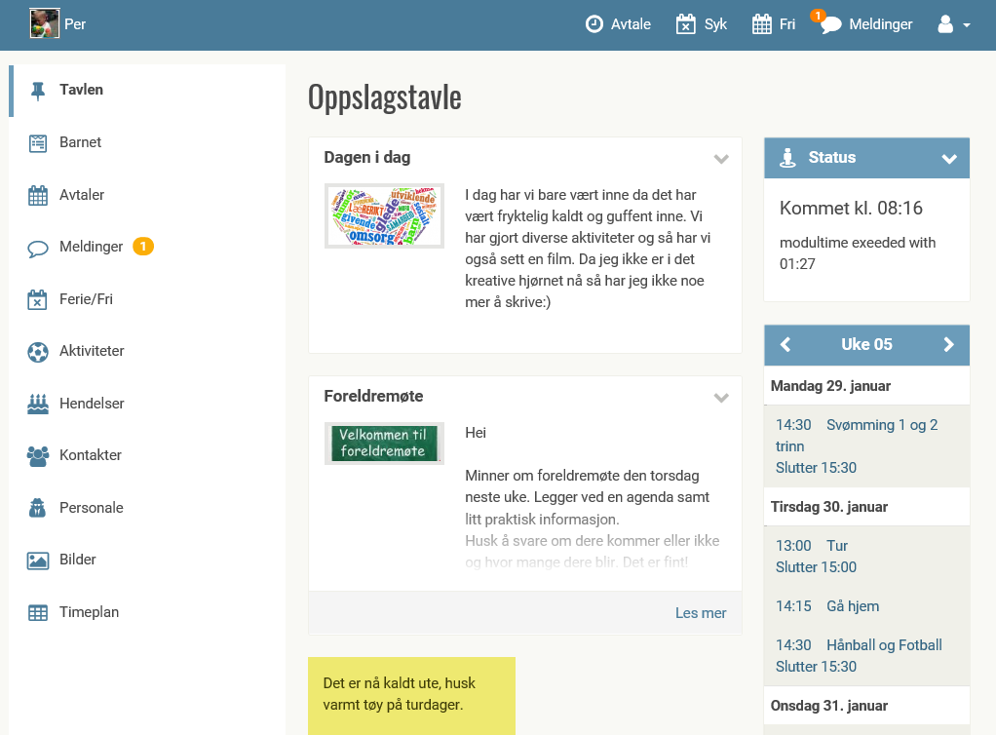
Here, parents and guardians can find information about the pilot project.
Status
Shows the child’s status. E.g. has arrived at the after school care centre, or has gone to the sports hall.
Calendar
Shows activities at the after school care centre. Users can register a child for an activity here. Clicking on Previous or Next highlights more weeks in the calendar.

The child
Permissions
Here is a list of permissions that the after school care centre would like parents and guardians to make decisions about. The user ticks the relevant box(es) to indicate which permissions he or she would like to give.
User profile/login
Here, parents and guardians can also create or change their own user names and passwords for the system. The password should contain at least 8 characters and include both upper and lowercase letters.
Arrangements
Under Arrangements, the parent or guardian can register a single or recurring arrangement. For example, that The child will be collected by his or her grandmother today at 15.00 or that The child will be collected by his or her grandmother every Monday. The page shows a summary of current arrangements, and users can register a new arrangement and change or delete an arrangement.

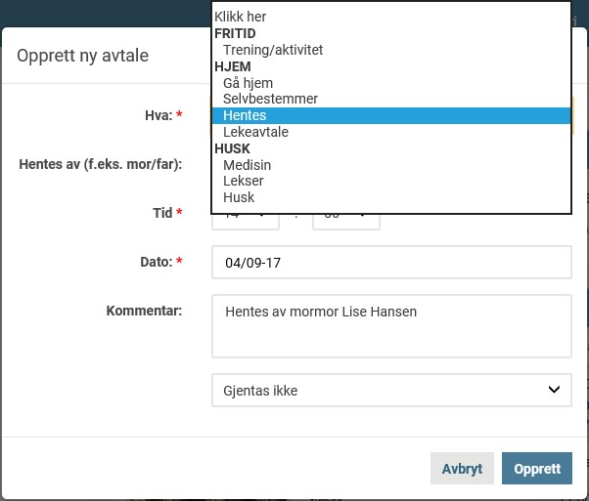
An arrangement might be Collected, Play date, Remember. Users can use the Play date arrangement to choose which friend the child is to go home with and the date. The parent or guardian cannot decide where and when the children will go home, however, as this is decided by the other child’s parent or guardian who will be taking the children home.
NB: If a regular arrangement needs to be carried over to the following school year, the End Date must be updated to the appropriate end date.

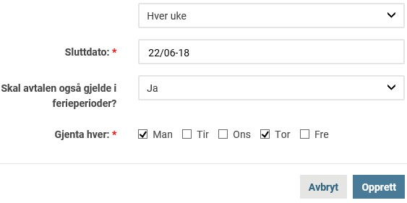

Example 1
William’s mother has arranged with John’s mother for their children to play together at John’s home in the afternoon.
- William’s mother registers an arrangement between William and John and indicates the date when her child is due to go home with John.
- John already has an arrangement to go home at 16.00 every day.
- The arrangement for William will look like this: Arrangement with John. Collected at 16.00. Going home with John.
- The arrangement for John will look like this: Arrangement with William. Collected at 16.00. William is to go home with John.
Example 2
William’s mother has arranged with John’s mother for their children to play together at John’s home in the afternoon.
- William’s mother registers an arrangement between William and John and indicates the date when William is due to go home with John.
- John already has an arrangement that allows him to decide when he goes home, between 15.30–16.00.
- The arrangement for William: Decides himself when he goes home between 15.30–16.00. Must go home with John.
- The arrangement for John: Decides himself when he goes home between 15.30–16.00.
William must go home with John.

NB: John’s parent or guardian does not have to change a recurring arrangement for John when a play date is arranged. Recurring arrangements are only used on days when there is no other arrangement.

Holidays/Days off
The menu item Holidays/Days off is divided into Holidays, which is linked to City of Oslo’s registered holiday periods, and Days off which fall outside the above holiday periods.

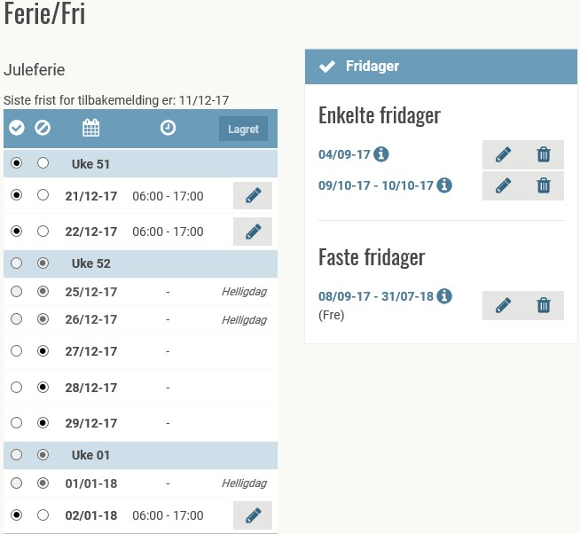

Days already registered are shown first. Registration of days off can be for just one day, several days, or recurring days.

Activities
The menu item Activities shows all activities offered by the after school care centre, both Enrolled and Not enrolled. This menu item also provides an option for displaying old activities. Users can only cancel enrolment in an activity by contacting the staff.

Events
The menu item Events shows family events. Family events are activities that the after school care centre would like parents to sign up for. For example, parent-teacher meetings and autumn exhibitions

Contacts
Under the menu item Contacts, parents and guardians can provide contact information for any other contacts connected with their child (in addition to the child’s parents or guardians).
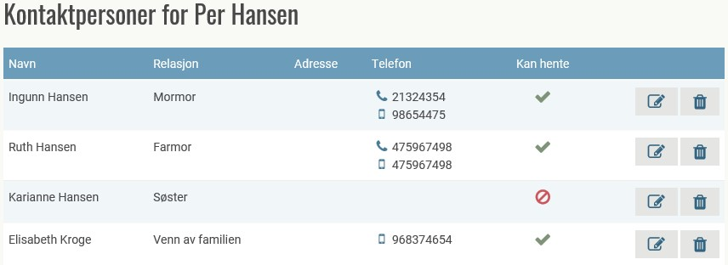

Staff
The Staff menu item shows a list of the after school care centre’s employees.

Timetable
Under the menu item Timetable, parents and guardians can register their child’s schedule. This is a weekly schedule in which parents or guardians indicate on which days of the week their child will be present and the approximate arrival and departure times. Staff can see these times which provide a helpful overview of when children are expected to be present.
The timetable can be registered as a recurring weekly schedule, or as a rolling weekly schedule lasting a specific number of weeks. For example, one weekly schedule for odd-numbered weeks and another one for even-numbered weeks.
The timetable always requires the approval of a staff member at the unit before it is activated.

